Mandy Smidt
CET 720
Assessment Review
ISTE Assessment
The International Society for Technology in Education (ISTE®) is a nonprofit professional organization with a worldwide membership of leaders and potential leaders in educational technology. They are dedicated to providing leadership and service to improve teaching and learning by advancing technology in the K-12 education as well as teach education. Their goal is to help educators incorporate various technologies into their schools.
There are multiple tools available for members to use through ISTE. During the 2004 and 2005 ISTE Leadership Symposia at NECC, ideas were brought together by different education leaders. With these ideas, a collection of tools was created to help make the case for educational technology. Included are stories, templates, starter kits, and other resources that help make the case for educational technology to a variety of audiences.
Some education resources include current Web sites, books, periodicals that relate to educational technology, lesson plans, and job postings as well for all to share. There are assessments including NETS Online Technology Assessment, Qwisdom Inc., Reading Success Lab Free Dyslexia Screening, Gradeconnnect, as well as other posted tools for others to use.
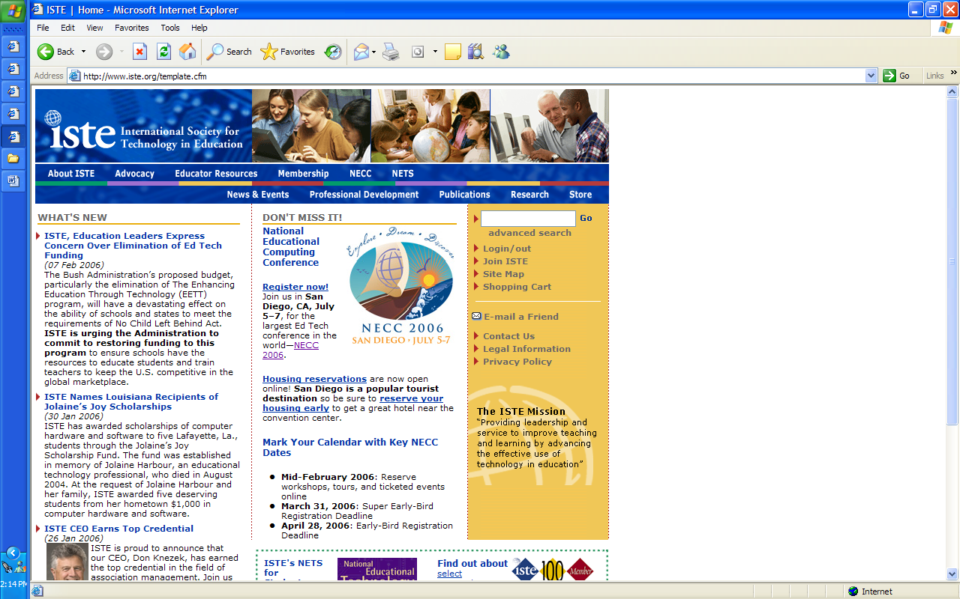

Various assessments are provided, including EasyWorksheet.com, which is a math problem generator organized by objective. Others include Gradeconnect.com,
There are membership fees at different prices. The “all-inclusive” fee of $195/year includes Learning and Leading with Technology, Journal of Research on Technology in Education, membership in all ISTE Special Interest Groups, plus discounts on ISTE products and services. The “standard” price includes a membership in one of the ISTE Special Interest Groups as well as one periodical plus discounts up to 25% on ISTE products and services. The “standard” membership starts at $79/year. Finally, the “student/retired” membership begins at $54/year with the same benefits as the “standard” membership, only it’s at a more affordable rate for the preservice teachers as well as the retired educators.
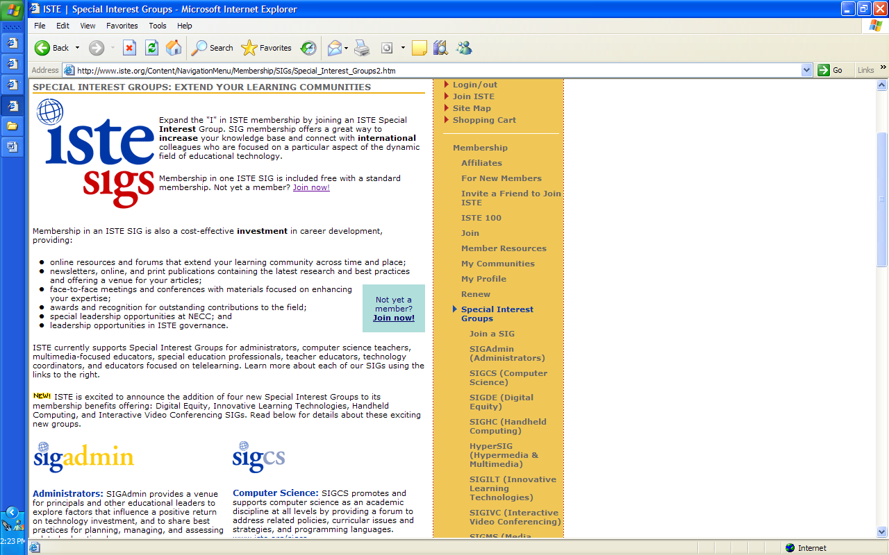

There is also “NETS online technology assessment” provided to help teachers measure their students’ skills by using software applications. It measures their progress towards meeting the National Educational Technology Standards for Students.
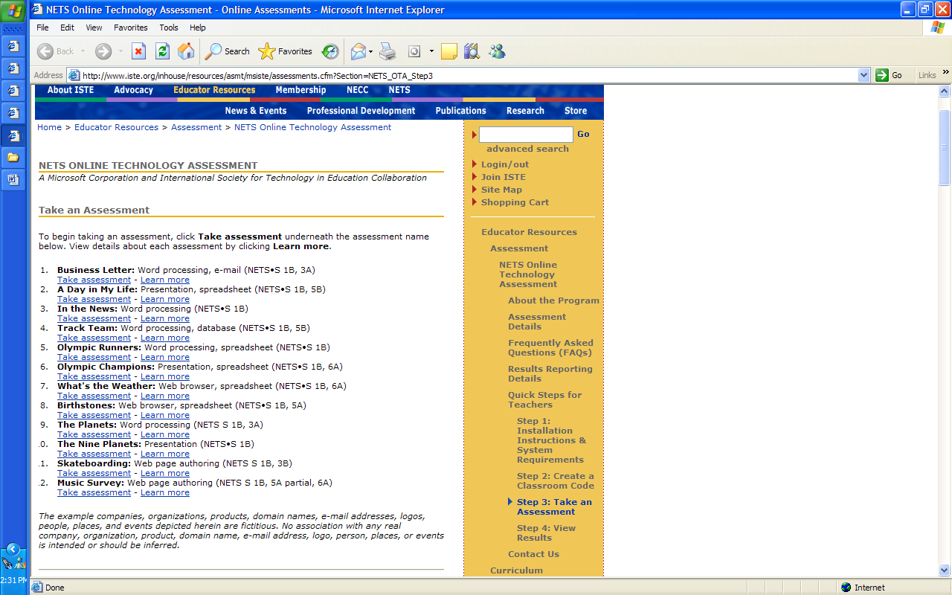.
Overall, I found the site to be somewhat useful. There are a lot of tools I haven’t really seen because I’m not a member. There are many different things available for teachers to use from an International view. I thought the NETS assessments were interesting. I would like to have students use it to see how they would like using it. Also, I thought the “Special Interest Groups” might be beneficial. Getting to know other instructors of the same teaching background could be valuable due to being able to try different teaching or assessment strategies that others may have.

